

**Festive Ice-Cream**

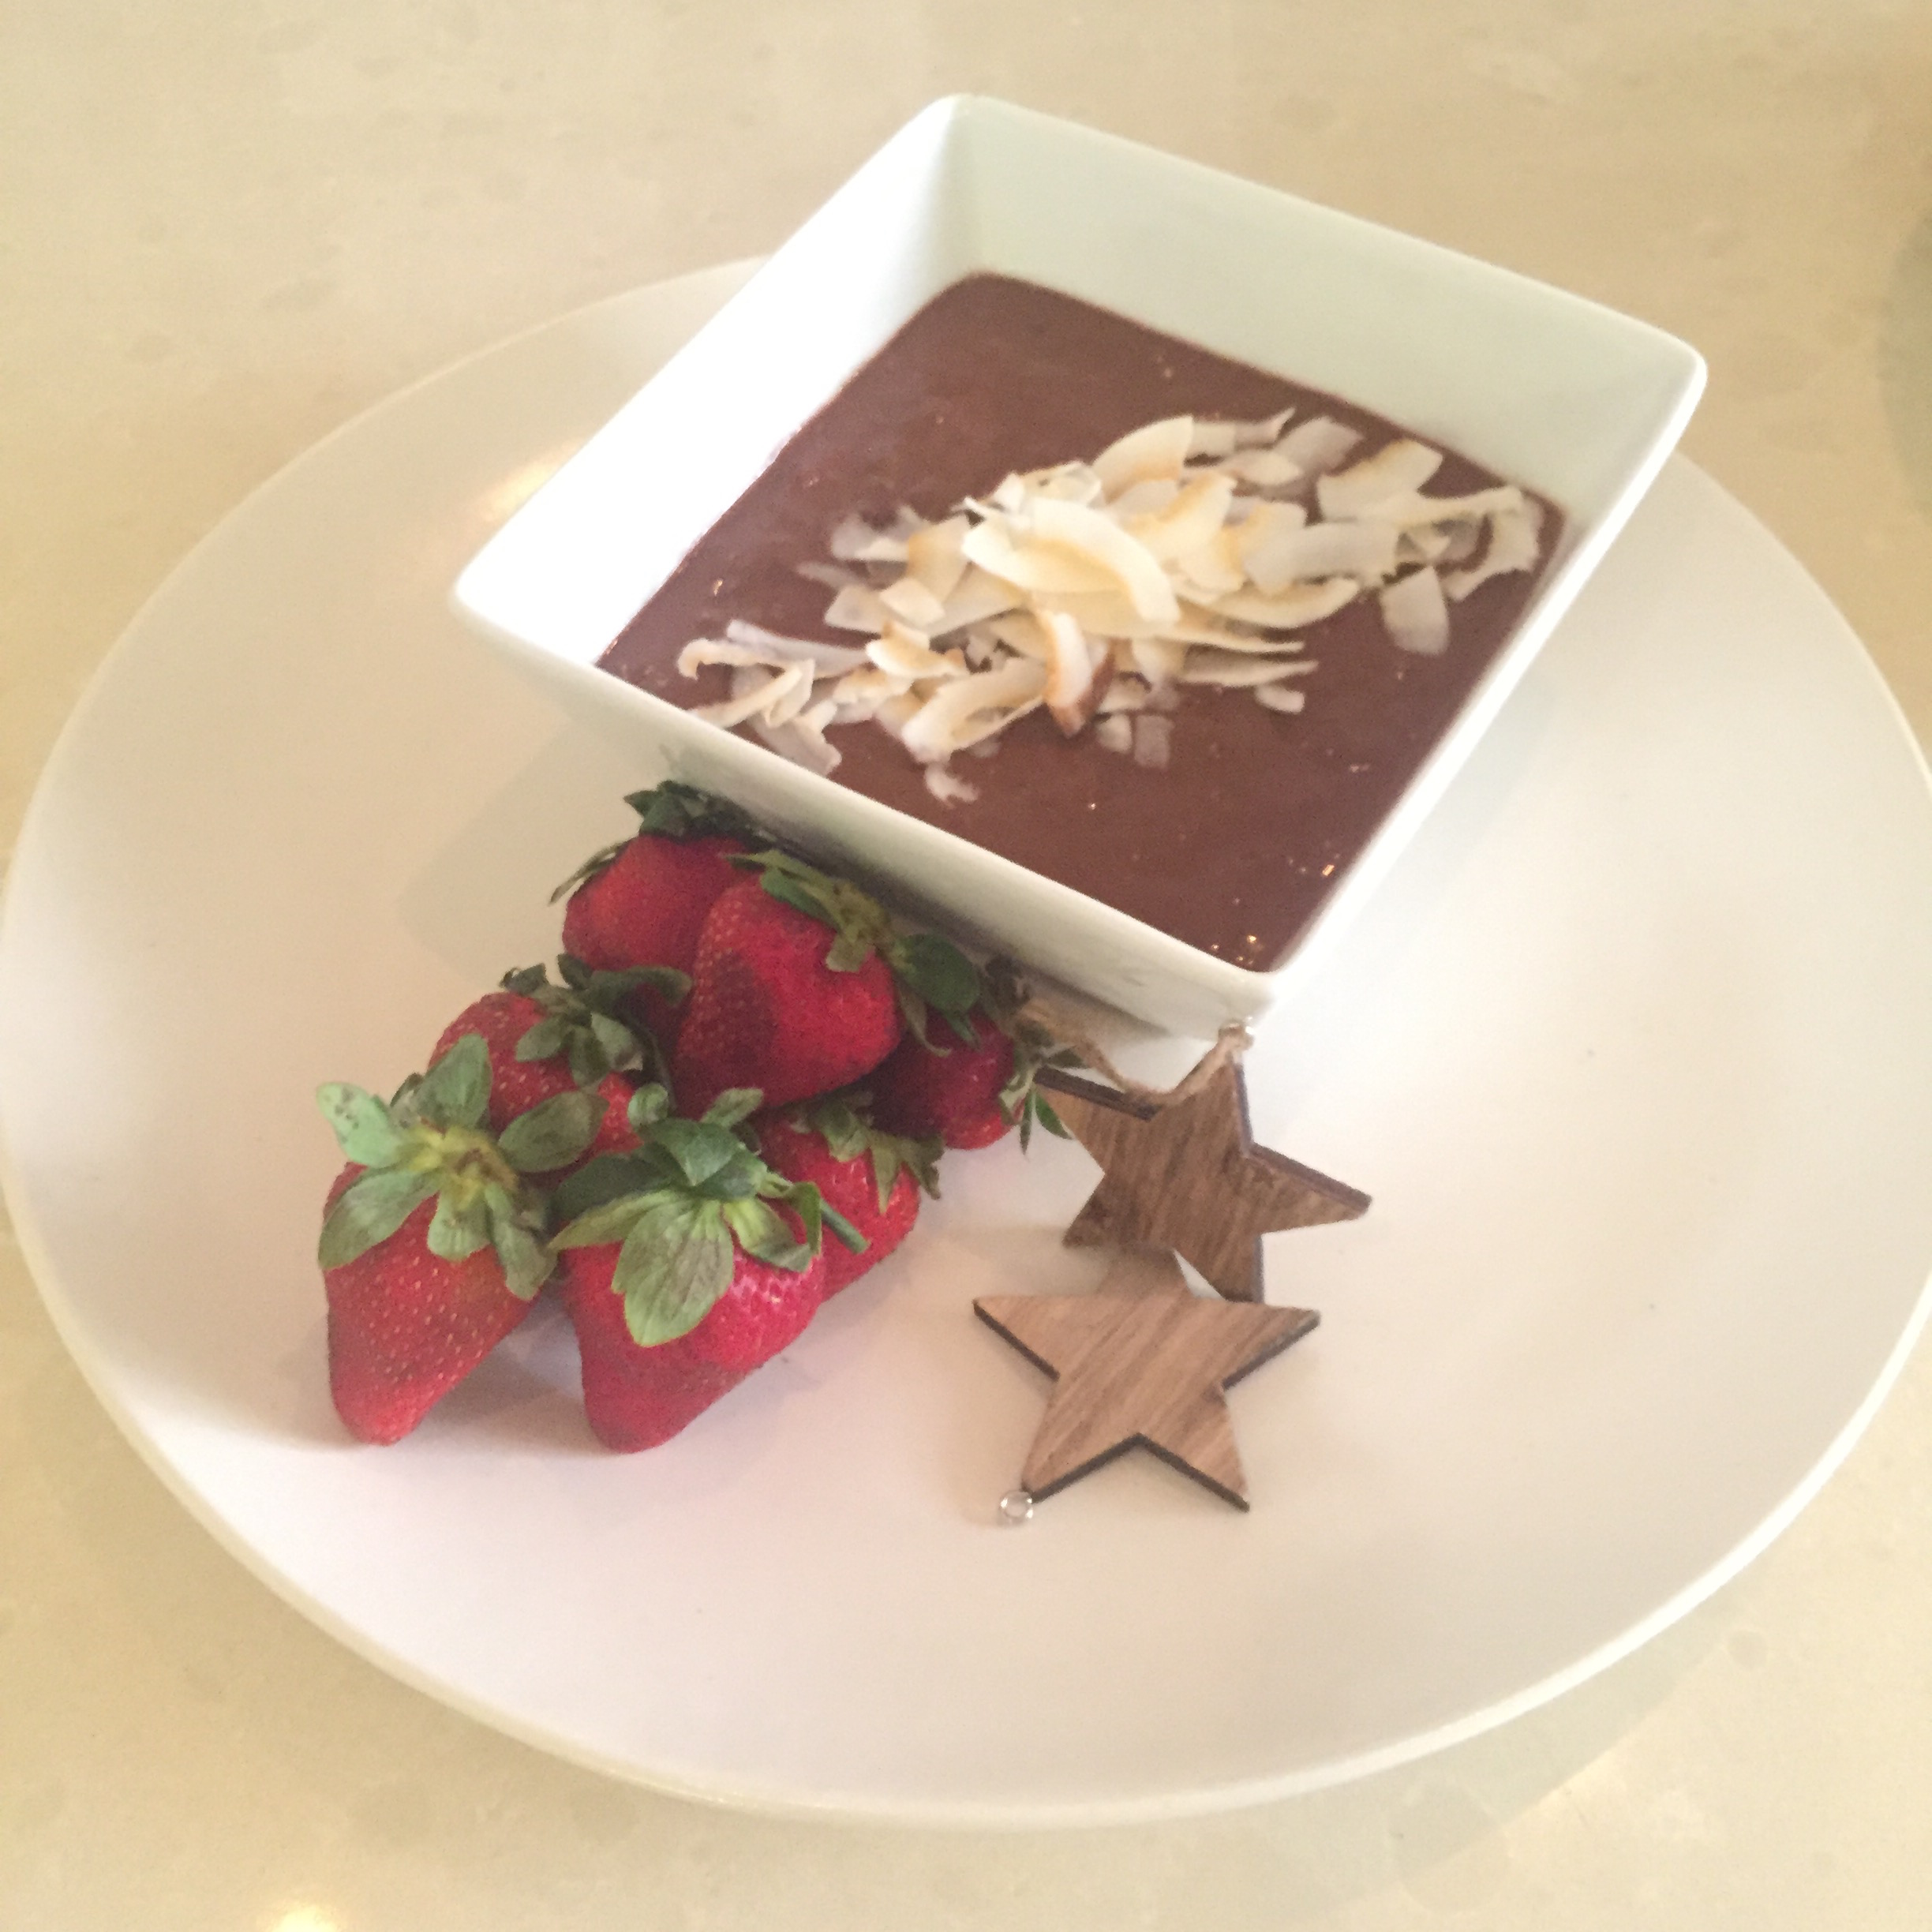

**Ingredients**

3 frozen peeled bananas

180mls coconut cream

1/2 cup cacao

1teaspoon vanilla paste

4 fresh dates seeded

Pinch of salt

2 tablespoons roasted macadamia nuts (chopped)

Toasted coconut shavings for garnish

**Method**

**Blend** bananas, coconut cream, cacao, vanilla, salt and dates in high speed blender.

**Fold** through macadamia nuts and garnish with toasted coconut shavings.

**Variations**

You could use almond milk instead of coconut milk or use half and half.