**Vegetable Quinoa Hotcakes**

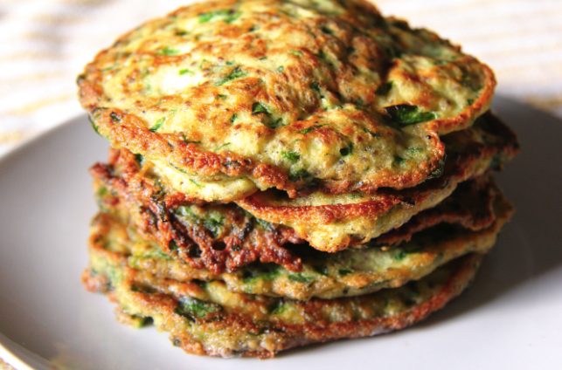

Hotcakes are a simple wholesome breakfast option. These are perfect for boxing-day brunch, particularly if you have a tribe to feed – just throw-in leftovers from Chrismas lunch. Then settle in for a movie!

**Ingredients**

1.5 cups grated zucchini (sprinkled with 1/2 teaspoon salt, left for 10 minutes then squeezed dry)

120 gms spelt flour

2.5 teaspoons baking powder

1 tbsp chia seeds

2 finely sliced green shallots

2 tbsps chopped dill

1 tbsps fresh mint chopped

1/2 cup cooked quinoa

2 eggs

1 cup natural yoghurt

50gms firm feta crumbled

Butter/ olive oil to fry

**Method**

**Mix** the following ingredients together in a bowl; flour, baking powder, chia seeds, shallots, quinoa, dill, mint and feta.

**Combine** eggs with yoghurt and mix into the dry mixture.

**Leave** for 15 minutes for baking powder to activate.

**Heat** butter until it sizzles and doesn’t burn, and equal olive oil.

**Place** spoonfuls of mixture into pan and cook both sides until cooked in middle.