**Coconut Five Spice Custard**

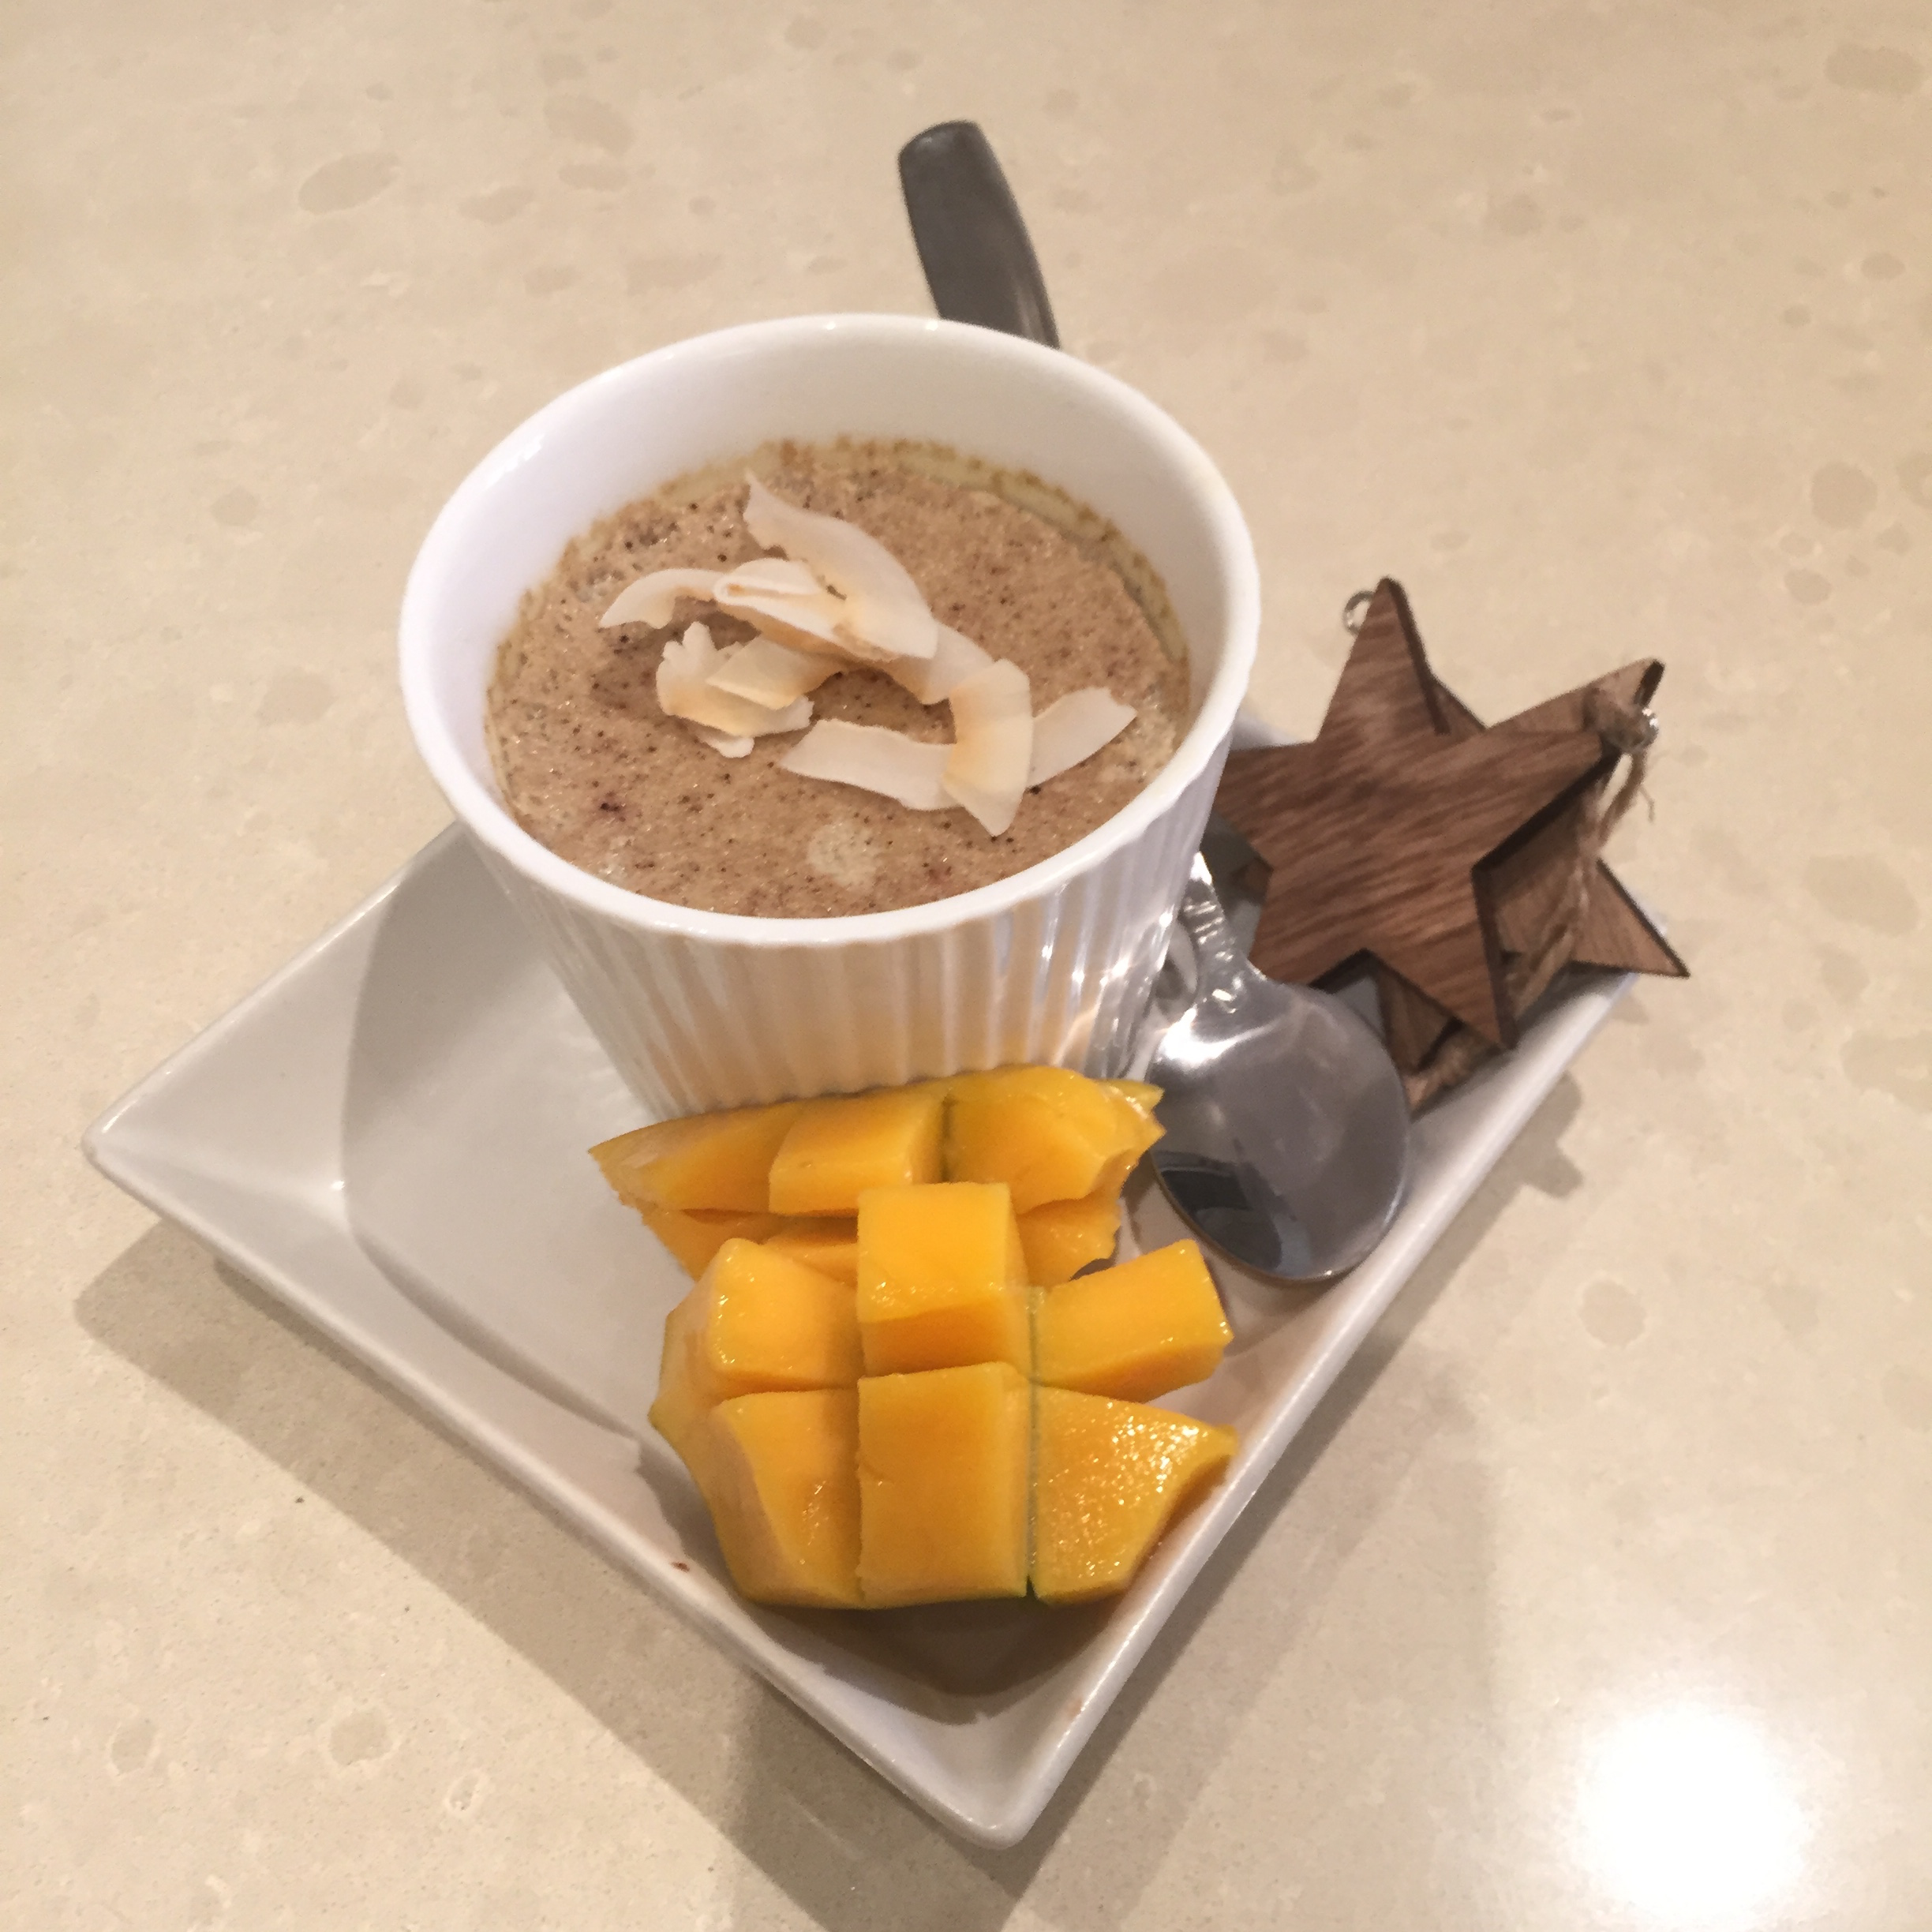

This custard delivers the traditional ‘sweet taste of Christmas’ with mixed spices, such as; cinnamon, cloves, nutmeg, etc. Your home will not only smell like Christmas when you make this but your guests will get to taste the true flavours of Christmas.

**Ingredients**

750ml coconut cream

1tsp five spice

½ tsp vanilla paste

5 eggs

2 fresh mangoes

**Method**

**Blend** all of the ingredients (excluding the mangoes) in a food processor until smooth.

**Next** pour mixture into small ramekins (150ml)

**Cook** steam at 90degress for 20mins (in either a steam over or over the stove in a bamboo basket

**Serve** remove the custards from the oven or off the stove and serve hot with some freshly sliced mango.

**Variations**

You can add a drizzle of maple syrup if you choose, and / or some toasted coconut shavings on top of the custard and / or some orange peel swirls/zest.